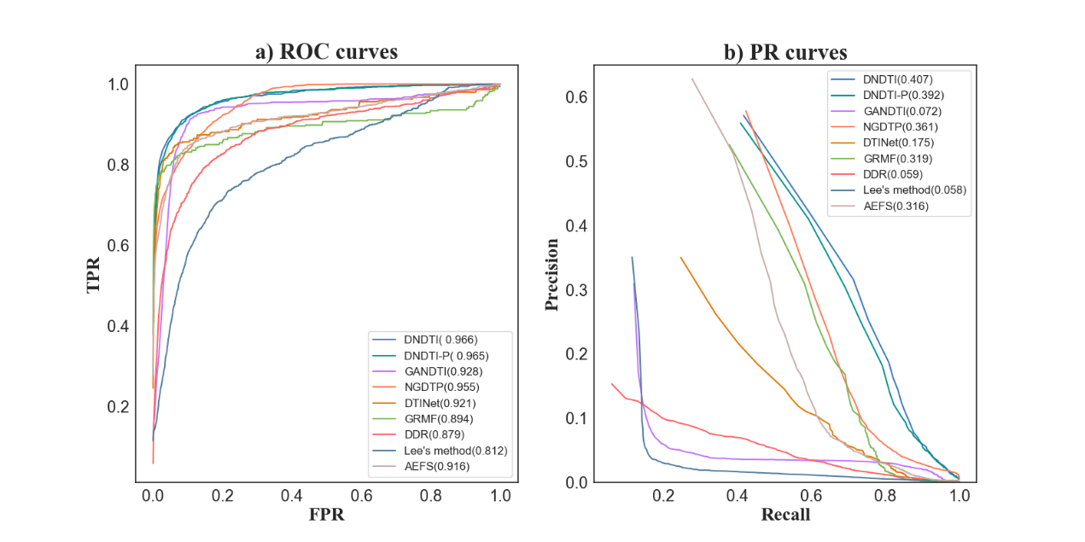

Supplementary Figure 2. ROC and PR curves of different DTI prediction methods (with DNDTI-P).